**Lab 12**

**Implement a Traffic Light controller using FSM.**



**Spring 2025**

Submitted by: **Mohsin Sajjad**

Registration No: **22pwsce2149**

Class Section: **A**

“On my honor, as student of University of Engineering and Technology, I have neither given nor received unauthorized assistance on this academic work.”



Student Signature: ______________

Submitted to:

**Engr. Faheem Jan**

Month Day, Year (28 05, 2025)

Department of Computer Systems Engineering

University of Engineering and Technology, Peshawar

**Implement a Traffic Light controller using FSM.**

**Objective:**

The lab this week will continue the introduction to FSMs with a simple Traffic Light Controller design project. In the lab, you are required to create a state diagram of a Mealy machine, which implements a traffic light controller, based on provided guidelines. You will then use this state diagram to write the behavioral Verilog description of the traffic light controller. The testing of your traffic light controller will take place during the lab session using the ISE development tools and the Spartan 6 board. As with the previous lab, we will make use of the character LEDs to display the outputs of our digital circuit.

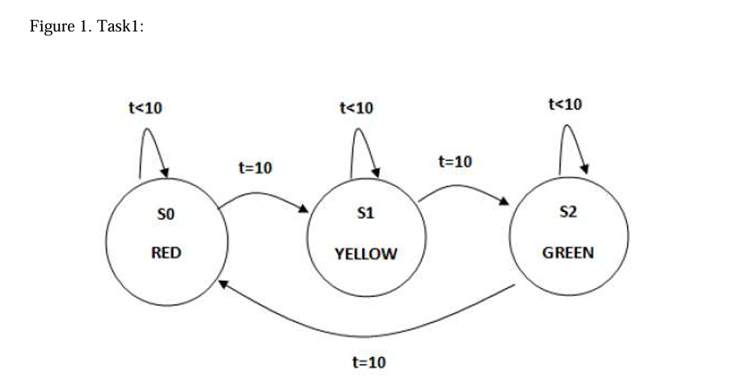

**CODE:**

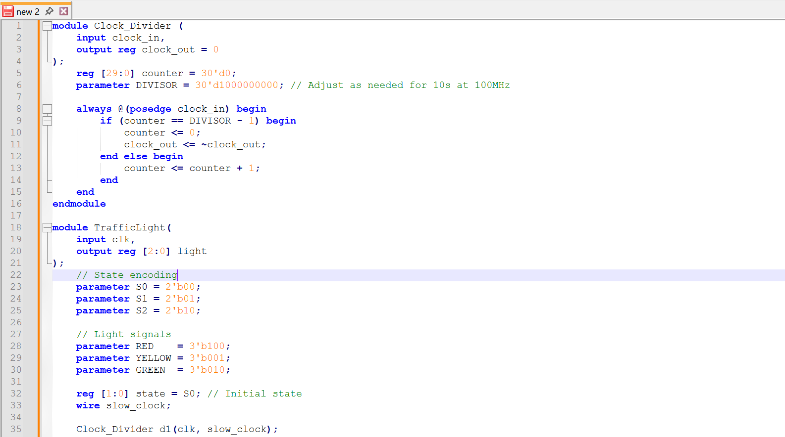

**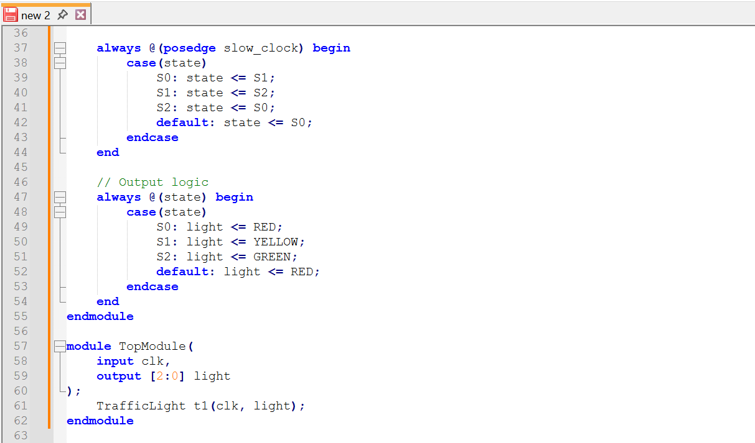  
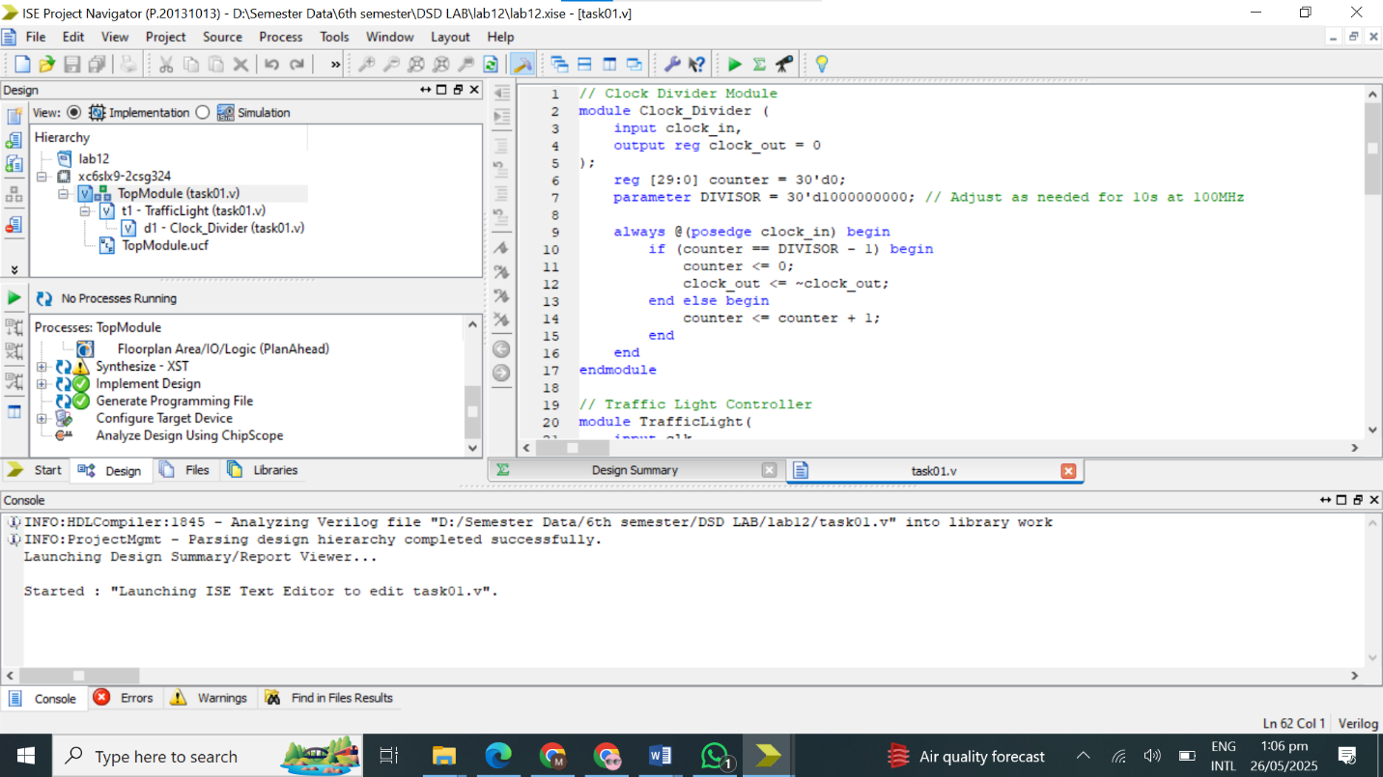**

**Output:  
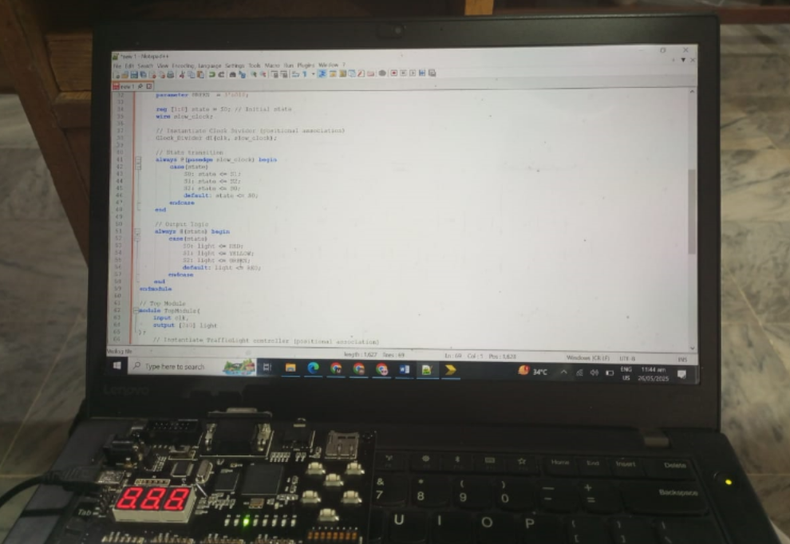**

**Task 02:**

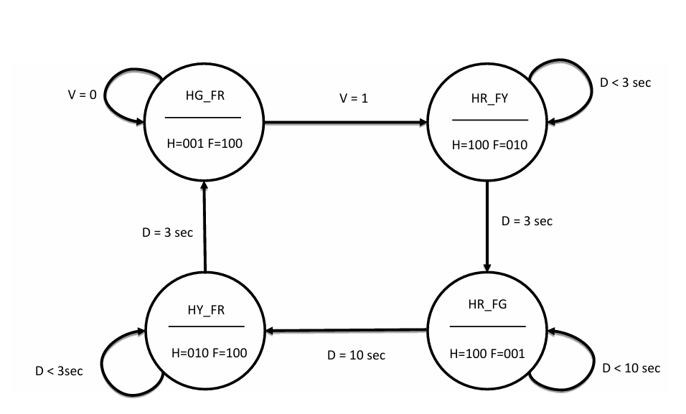

**CODE:  
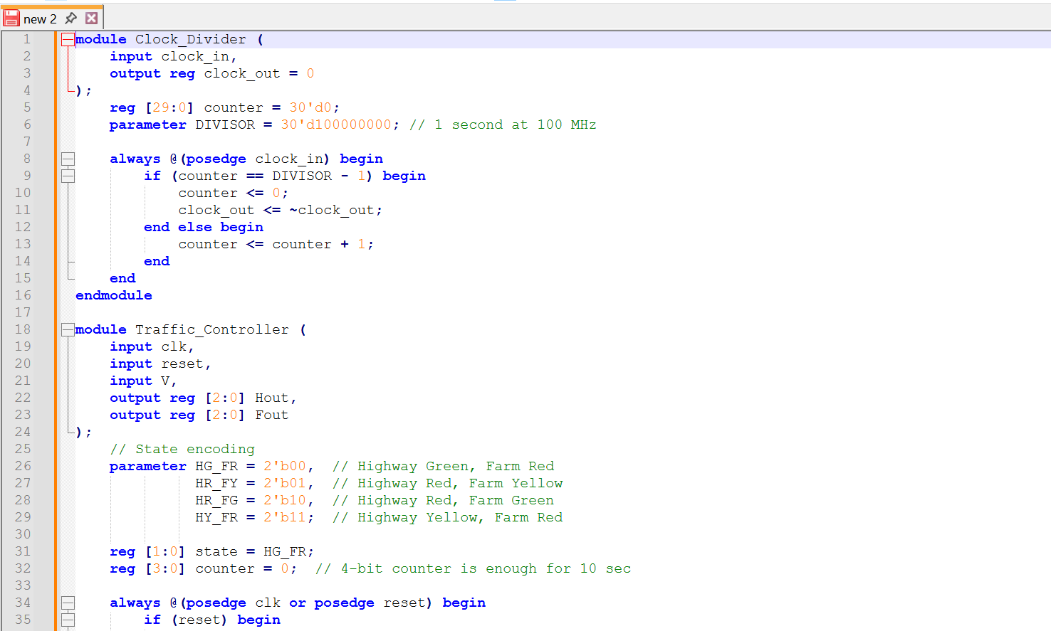**

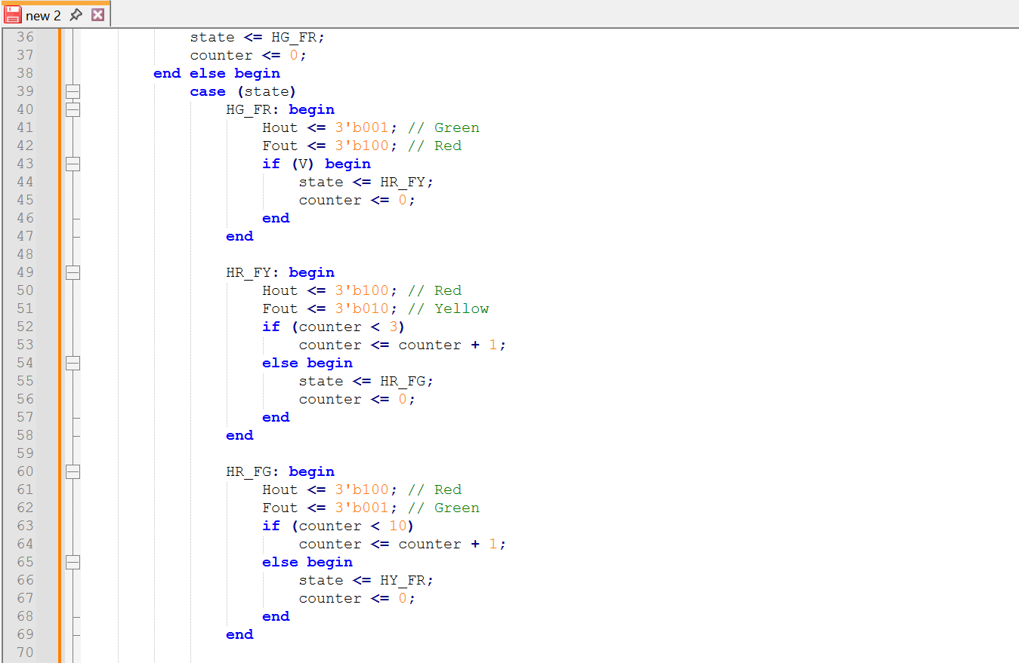

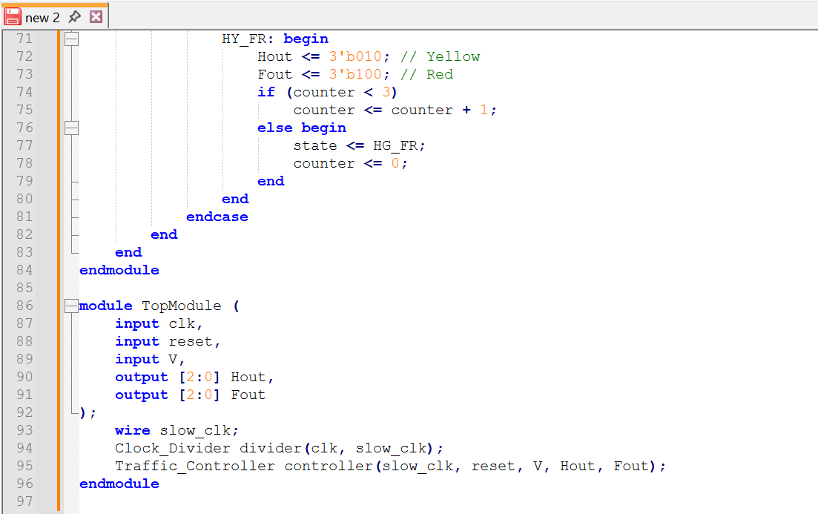

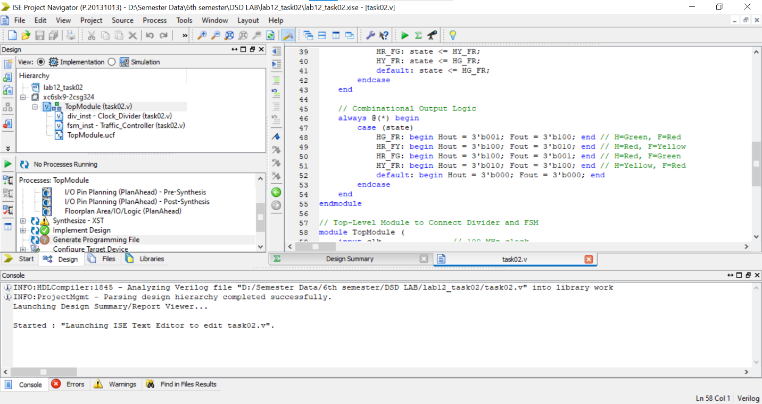

**Output:**

